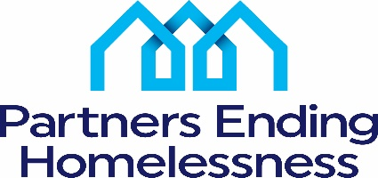

560 West Main Street

Rochester, New York 14608

585-319-5029

[csanderson@letsendhomelessness.org](mailto:csanderson@letsendhomelessness.org)

July 27, 2022

Tree Clemonds

Providence Housing Development Corp.

1150 Buffalo Road

Rochester, NY 14624

Dear Ms. Clemonds,

Partners Ending Homelessness is pleased to support Providence Housing Development Corporation’s application for Monroe County ARPA funding. The proposed project, the Door of Hope will provide Rapid Re-Housing to individuals and households with children who are fleeing domestic violence and human trafficking. Door of Hope will provide one year of rental assistance and two years of support services to participants to ensure a successful transition to permanent housing.

Providence is currently an active partner in the homeless system and has extensive experience in providing permanent supportive housing and rapid re-housing programs.

Please feel free to contact me if you have any questions or need further information.

Thank you!

Sincerely,



Connie Sanderson

Executive Director